Welcome to This Free Online Transforming Depression Into Hope Course. Take your time and use these tools to put depression into your past and where you will live a

The Thing about Depression is ……………..

Introduction
Last week I was sitting in my office with Anne, at this stage we had seen each other for only 3 weeks. There was an incredible sadness in her eyes. She was numb, lifeless and somewhat soulless. Sometimes this is called emotional numbness. There was blankness in her face, the product of approximately 15 years of different types of anti-depressants. When I asked her to describe herself she said ‘I am a middle aged depressed women’. It’s strange the lenses we wear. What I saw in front of me was totally different. Anne was a kind, wonderful, sensible, hardworking, practical, generous, humorous, brave and creative woman. That’s what depression does to people it hollow outs the person stripping them of their heart, life, mind, energy and soul.

You can estimate if you are currently depression by completing the depression self-test questionnaire. You can also use the self-test questionnaire to track your progress as you use the tools I will provide in the second part of this chapter, Transforming Depression into Hope. Remember the self-test is only a guide and does not make a diagnosis or healthcare recommendation. I recommend that you attend your GP or qualified mental health expert for thorough clinical assessment for appropriate diagnosis and treatment.

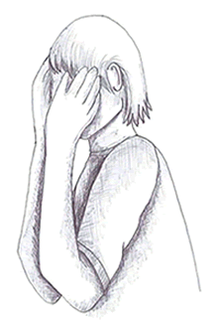

Let’s see if you have Symptoms of Depression?

Depression Questionnaire
Please Tick
Feelings
Sad / Low / Flat YES NO
Hopelessness YES NO
Tearful YES NO
Miserable YES NO
Irritable / Angry YES NO
Lonely YES NO
Unmotivated YES NO
Lost YES NO
Overwhelmed YES NO
Anxious YES NO

Physical (Body) Symptoms
Poor Concentration YES NO
Increased or decreased appetite YES NO
Low Energy YES NO
No interest in Sex YES NO
Disturbed sleep YES NO
– Difficulty getting off to and Staying Asleep

Behavioural Patterns
Wanting to spend more and more time alone YES NO
Staying in bed longer than usual YES NO
Stop doing things I used to enjoy YES NO
Having more arguments YES NO
Being restless & agitated YES NO
Losing many of my interest in other people or things YES NO

Thinking Symptoms
Self-Worth: I feel worthless YES NO
Pessimistic: Things will never change YES NO
Failure: As I look back, I see a lot of failures YES NO
Self-Critical: I criticise myself for all my faults YES NO
Confidence: I have lost confidence in myself YES NO
Hopelessness: I feel hopeless YES NO
Guilty: I feel guilty YES NO

Red Flags If you tick yes to these questions go and see your GP immediately

I have thoughts of killing myself but would not carry it out YES NO
I would kill myself if I had the opportunity YES NO

If you have ticked any three from each area please go and see your GP.

Depression
Everyone experiences sadness during their lives, and it is important to distinguish between this sadness and depression. Many health professionals are too quick to medicalise sadnesss and reactions to major life events such as redundancy, bereavement, marital breakdown as depression. Nevertheless when you are finding it difficult to escape from this low mood and sad feeling after a period of time e.g. two or more weeks it is best to seek early intervention.
A good first port of call is your GP.

The Power of Labels
When I first meet individuals struggling with mental health difficulties I always try to explore what their sense of the problem is. I am always amazed how quickly people label themselves as depressed. Now I may be a little unfair as I think about depression in the context of clinical depression not the laypersons use of the word depression. I think it’s important to challenge the labels we give ourselves. Sometimes I describe it like a train journey between Dublin and Cork where the person is ‘Not Depressed or Depressed’, it’s as if there were no stops.

NOT DEPRESSED DEPRESSED
Dublin ================================================== Cork

(Ps I am not saying Cork is a depressed city!)

If you think about depression like this there is no place to get off the train. It’s a one way ticket where the journey ends with hopelessness, despair and pain. The labels we give ourselves are very powerful in terms of ‘keeping the problem going’. If we are on a train that only has one destination then we can only feel one thing, depression. People start to live the label ‘I am depressed’. In turn the things we think, feel and do fall follow the pattern of the label we give ourselves. We can feel even more hopeless and desperate. We end of thinking in black and white or ‘all or nothing’ terms – thoughts that continually run around our head could be - I am no good, nobody loves me, life is totally crap, and nothing matters. Then we start doing things that we have not done before, staying in bed, not returning phone calls, and zoning out rather than tuning in.

Here’s the thing I accept there is depression but I also think before we get to that place there are many stop offs on the train journey. Each stop off gives us the opportunity to reverse the journey or to take a branch line to a better place .

Just OK -- Upset --- Low – Sad – Distraught ---------------- depressed

(Waterford branch line)
Dublin ==== Kildare ======= Portarlington ====== Limerick Junction ===== Cork
(Galway Branch line)

The challenge is to avoid the all or nothing thinking and to identify our emotions appropriately.

For example Mary 54 years is referred by her GP with depression. She diligently takes her anti-depressants. Her husband 55 years has terminal cancer she is distraught. She describes that Michael was the love of her life. They met as teenagers and against the wishes of both set of parents the charted their course in life. They had two children and she would describe how they borrowed a neighbours mobile home and went down to Tramore for a week. They had little money at the start but lots of love. She described supper on holidays a loaf of fresh sliced pan, some ham and a portions of chips from the local chipper. They sat on the beach drinking looking at the waves sipping the Club Orange. Now she looks at the chemotherapy line, the bloated body of Michael due to steroids and a 1 year prognosis. Is this depression? Now in fairness it could be but its needs close assessment. It turns out that Mary mood is down but she is not depressed. She is grieving. In the literature it’s called anticipatory grief that is the grief we experience associated with a future loss. This grieving is profound Mary is trying to come to terms with the loss of Michael, the loss of her future life with Michael, the loss of their shared plans and dreams.

Let’s not medicalise normal sadness. When we learn to label our emotions more accurately we set up the opportunity to get off the train that has only one destination. Mary needed a space to express her profound sadness, grief, hopelessness, despair and loss. Mary needed to process these feeling. Taking a pill, something external to change your brain chemistry was not the answer for Mary. She needed to feel the pain, the only way through grief is to go all the way in and the only way to get past grief is to go through it. Scary.

Now let’s look at the clinical depression, Bipolar and post natal depression.

Depression.

Depression is one of the most significant public health problems in Ireland. Clinical depression impacts on our feelings, our thoughts, our bodies and what we do. It robs us from being our real selves. A person can feel – sad, pessimistic, hopeless, self-hatred, weak, doubtful, loss of pleasure, guilt, angry, irritable, pain, anxiety, bleak, cold and isolated.
A person thoughts when depressed include – suicidal thoughts, self-dislike – I am disappointed in myself, a sense of being punished, my future is hopeless and will only get worse, I am a failure, It’s my fault I am like this, I am useless, I am not interested in anything, I am more indecisive – I am stupid I can’t even make a simple decision, I feel worthless
Depression impacts on our actions – crying, avoiding and withdrawn, procrastinate, shouting and arguing, pacing, and staying in bed.

Depression impact on our bodies – tiredness, fatigue, sleep disturbance – sleeping most of the day or waking up 1-2 hours early and not being able to get back to sleep, low energy, restless wound up agitated, changes in appetite – from no interest to cravings, concentration difficulties, and a loss in interest in sex.

Depression can be long-lasting or recurrent, substantially impairing a person’s ability to function at work, school or cope with daily life.

Key Warning Signs about depression or Red Flags
There are a number of red flags I would like to raise. As clinicians we get very concerned when we hear individuals reporting:

‘Suicidal thoughts’ we distinguish between - suicide ideation and suicide intent.
- Suicide ideation is having thoughts about suicide but would not carry them out. These are common thoughts for people with depression and are a symptom of depression. In the therapy situation we make a contract with the individual to commit to their safety during therapy. With successful therapy these thoughts lift with the depression.
- Suicide intent is where person is moving towards suicide having thoughts of how and where. This is an emergency and requires immediate intervention, where the person is brought to A&E for a comprehensive assessment and commencement of treatment.

Other key warning signs include
- ‘early morning awakening – waking up 1-2 hours early and not being able to get back to sleep’ this is a red flag of the biological side of depression.
- Withdrawing from friends, family, and life
- Giving away possessions
- Sudden improvement in mood after being down or withdrawn
- ‘Feeling trapped’ – like there is now way out
- Dramatic mood changes
- Increasing alcohol or drug use
- Hopelessness: How a person feels about their future seeing no reason for living or how hopeless they feel or thinking they have no purpose in life

If you are experiencing any of these symptoms seek assistance from your General Practitioner immediately.

Just snap out of it - If only.
Depression is cruel it robs the life out of you. It’s not possible to just snap out of it. Most people with depression would trade it for a broken leg, even two. John says ‘at least a broken leg is visible, my depression is invisible. I am in pain. It’s a deep internal pain, some days I want to curl up and sleep and not get up. In work if I had a broken leg I can get time off, I can’t ask for time off with my depression, she wouldn’t understand. A broken leg is nothing to the pain of depression, believe me I broke my leg playing football. You find out your true friends with depression as most disappear when they find out that you have been in hospital. Not that I could go into hospital in my local area. I just couldn’t face that. For me depression is a failure of my personality, it shows that I am weak. To think I have to take tablets every day to make myself feel ok’

When I hear John talk I hear the pain of his depression and also how depression is seeping into his thinking, body and actions. Depression is a thief, it disconnects us from ourselves and our loved ones.

Transforming Depression Into Hope
When depression lifts, hope remerges. With this hope there is perspective, renewed energy, engagement and connection. When I read about treatments for depression two primary options are most often discussed Medical Approach & Talking Therapies: The NICE National Institute for Health and Care Excellence www.nice.org.uk provides independent, evidence-based guidelines for the United Kingdom National Health Service (NHS) on the most effective ways to treat disease and ill-health. At present we have no comparative organisation in Ireland providing guidelines for the Irish health service. NICE is one of the foremost academic and research institutes that identifies guidance for clinicians in the treatment of different conditions such as depression.

Talking Therapies for Depression As Evidenced by the National Institute for Health and Care Excellence www.nice.org.uk

Cognitive Behavioural Therapy CBT
CBT looks at how we think (cognitive), feel, our behaviours (actions), our body reactions in given situations. . There is a great deal of research evidence to show that CBT works effectively in treating depression. Therapist and client work together in changing clients behaviours and thinking patterns. CBT is offered in a one-to-one or group situations. Generally a session lasts 60 minutes. Most people like CBT because it is focused on the ‘here and now’ rather than in the past. It is practical and action orientated.

Further evidence supported treatments & Adjuncts for Depression

Self help Books
Bibliotherapy is the use of self help books for therapeutic purposes. The effectiveness of self help books has been well established in clinical trials and is recommended by National Institute for Health and Clinical Excellence (NICE) UK as a useful start in treating mild and moderate depression along with other presentations.

Computerised Cognitive Behavioural Therapy Programs
I often recommend free online CBT therapy programs such as the MoodGYM (www.moodgym.anu.edu.au) to assist individuals address depression. They can play an important role in tackling mild depression or can be used in conjunction with other approaches for transforming moderate depression.

Exercise
There is increasing evidence to support the role of exercise in tackling mild to moderate depression. Exercise be it walking, jogging, cycling, dancing or swimming all help release endorphins. These are our bodies ‘feel good’ hormones. Regular exercise has shown to reduce stress, boost self-esteem and improve sleep all which positively impact on depression. I recommend that clients walk 3-4 times a week for 30 minutes. For some this obviously has to be built up. Building a good exercise habit is very important in maintaining good health after depression has gone and acts as a very good early warning sign for recurrence.

Nutrition
Having worked on Operation Transformation for many years and read considerably on how nutrition and mood are related I am convinced that there is a strong link. The overconsumption of energy dense processed foods that are high in fats, salt, sugar such as prepared meals, cheeseburgers, French fries and donuts sap the vitality from the individual. My psychology background does not allow me to make specific recommendations around nutritional supplements. It’s an area I would like to explore more. It’s a bit of a conflict for me as I don’t want to introduce a tablet be it a nutritional supplement when my goal is to reduce individuals dependencies on antidepressant medication. Sometimes when you introduce supplements any lift in mood is associated with the tablet and not the therapy. Given all that it’s important that if you are experiencing depression and low mood that you eat a varied and healthy diet and optimise your nutritional status. For further reading on this check out Patrick Holford book - Optimum Nutrition For The Mind

Mindfulness
Mindfulness is the practice of being present in the now by directing our attention to what is happening right now. When mindful you work from the stance of compassion towards yourself and your experiences. There is increasing evidence to demonstrate the effectiveness of mindfulness in treatment of depression and importantly preventing relapse. When mindful you are aware of what you’re doing while you are doing it. When mindful you will be more aware of incoming thoughts and feelings. In depression these thoughts are more often negative automatic thoughts (NATS). When mindful the difference is you do not attach meaning or react to the thoughts you just observed and except them without judgement. In effect you do not get snared by these NATS and the negative feelings that are associated with them. Because you are not your thoughts. Often I imagine mindfulness is like the scene in the movie The Matrix where Neo played by Keanu Reeves gets to such a powerful level of awareness and being in the moment that he is able to dodge bullets. In a way these bullets represent NATS, imagine you can be aware of them but not overwhelmed by them. This is so liberating. Like any new skill it takes practice and commitment. It’s worth it. Check out my website www.dreddiemurphy.ie for details of courses.

Support Groups
AWARE www.aware.ie and GROW (www.grow.ie) are two support groups that provide information and support for individuals experiencing depression. Support groups can play an important role in tackling depression. Support groups provide social support.

Talking & Relationships As human beings we all have a need to belong. Another way of thinking about social support is that it of a ‘relationship’. The relationships we make provide a safety net from isolation. This social support be it from family, friends or groups is a vital and effective part of recovery from depression. Talk to friends and family members you can trust. The old adage ‘that a problem shared is a problem halved’ has stood the test of time. It limits the damage of isolation that impacts on how a depressed person looks on the world and offers alternative and positive solutions to eat recovery from depression.

Alcohol and Drugs
A word on alcohol and drugs. Don’t. Alcohol is a depressant. While it might offer some temporary relief it doesn’t last. Drinking stops you dealing with the issue. It’s a way of zoning out and numbing yourself. Stopping drinking even for a period of time can have an incredible effect on low mood. In many situations I’ve seen people who have come to see me with mild to moderate depression. For some individuals I asked them to commit the periods of absence from alcohol. Others do it without asking. This said they were okay with this as there was no addiction involved. Over a short period of intervention say six sessions over three months individuals report remarkable improvement. The key role in this improvement is the benefits from the absence of alcohol - the increased energy, better sleeping pattern etc. I cannot overstate how much staying away from alcohol helps tackle depression.

Conclusion
As you can see there are various options available to a person who is depressed. Exploring your options will help you decide what intervention mix is most likely to work best for your particular situation and needs.

THE CBT MIX FOR DEPRESSION
CBT has extensive clinical trials to indicate that it reliably helps overcome depression. I use this approach combining it with those mentioned above in order to create a unique blend for the individual while also ensuring that it has the best scientific basis and proven good outcomes.

The 5 Hats of CBT

A good way of thinking about the CBT model is to think of 5 interlinking areas or ‘hats’ – Situation, Thought, Feelings, Behaviour, Body (Physical reactions).

Example of using behavioural activation

Anne is 35 and works as a receptionist 3 days a week in a dental surgery. Two years ago her mother died and although very sad felt that she coped well. A year ago a long-term relationship had broken down and since then has felt depressed. As result of the death of her mother and loss of relationship, and subsequent depression she has lost contact with many friends and rarely meets other people or socialises other than at work. Consequently she no longer engages in any of her previously enjoyed activities such as going to the cinema, days out at the weekends and going for a drink in the local pub. Anne said that in the evenings and at weekends she does very little except watch television, she used to enjoy gardening but says ‘I just do not seem to be able to get going’. Anne also did not do many other things she had stopped reading the daily paper and did not have it delivered any more. She used to go to the local library at least once a week and read 2-3 books weekly. Since she has been depressed she has not been to the library and has not read.

Anne defined her problems and goals as:

Problem 1
Feeling depressed and miserable for the last year and I have not been able to motivate myself to do the things I used to enjoy doing.
2
4
8

Time 1 Time 2 Time 3

Goal 1 To read a newspaper or a book for at least 30 minutes everyday
1
0
8

Time 1 Time 2 Time 3
Goal 2 To go to the cinema once a week either alone or with a friend
8
2
4

Time 1 Time 2 Time 3

Goal 3 To join a nightclass and go every week
8
5
2

Time 1 Time 2 Time 3
Anne felt that behavioural activation would be the most useful intervention. Anne decided to set herself a few tasks for the following week (see diary below). Anne managed to achieve all her tasks and was surprised how good it felt. Ringing her friend was the task that she achieved most pleasure as her friend had asked to meet up with her the following week.

 | Monday | Tuesday | Wednesday | Thursday | Friday | Saturday | Sunday
9-10 | Work | Work | Work | Read paper for 30 minutes  A = 5  P = 3 | Read paper for 30 mins  A = 5  P = 3 | Read paper for 30 mins  A = 5  P = 4 | Read paper for 30 mins  A = 5  P = 4

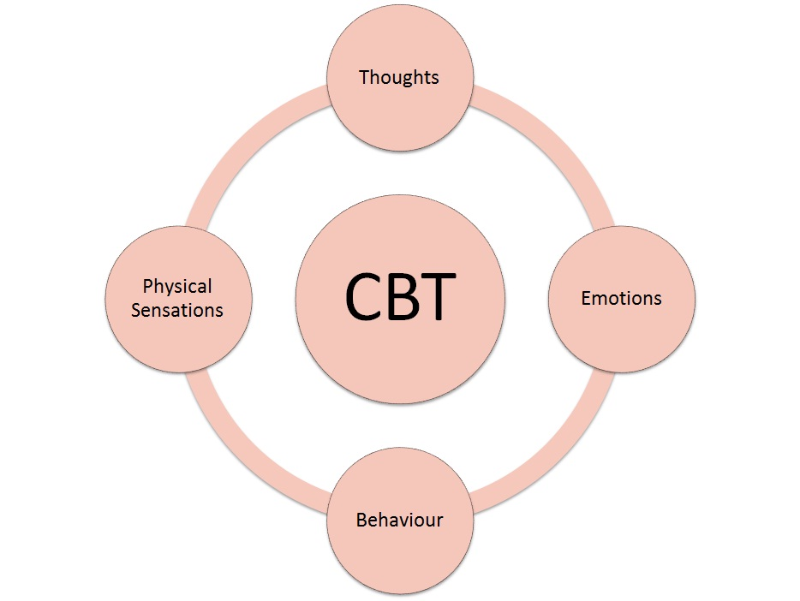

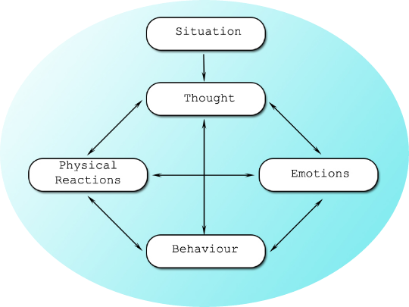

Situation: is the "who, what, when, where, why" element, it includes the environment that you find yourself in and gives rise to the thought.
Thoughts: it’s the internal chatter that goes on in our heads.
Feelings : Our emotions or mood. How we feel.
Behaviours: Our actions, what we do
Body (Physical Reactions): How our body reacts.

For Example:

Situation: Mary was in town shopping and happened to walk by Anne her good friend, who ignored Mary.

Out of this situation Mary had many:

Thoughts ‘she couldn’t stop for a quick chat, why, I must have upset her, or maybe Anne does not like me anymore’ ‘I know I have been feeling down lately people must think I there is nothing pleasurable about my company. Sure who would want to hang out with me may be Anne is right’

Our thoughts are essential to our emotions
Feelings, thinking Anne did not like her Mary feelings were ‘Sad & Rejected’.
Our thoughts/feelings are closely linked to our
Body (Physical reactions). Mary feeling sad and rejected, in her body (physical reaction) this is reflected as low energy, downbeat body language, and tearfulness.

Finally,
Behaviour - what we do next from this situation. Mary, feeling sad and rejected, decided to go home immediately, she was due to see Sean another friend that evening and decided to cancel it. Later that day and happened to phone and Mary did not answer.

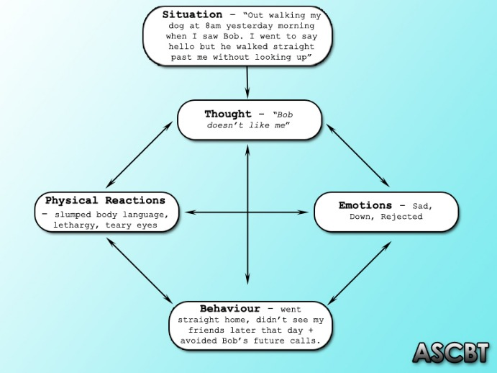

As you can see the five hats of CBT all interlink. What is interesting is the Thoughts that Mary had about the Situation, influenced her Feelings, Body, and Behaviours. Imagine in the same situation Mary had different thoughts for example

‘Anne must have been daydreaming, she did not see me at all. She has been worried about her mom who was in hospital recently’

Given this thought how do you think Mary would feel?

Feelings: Mary feelings were now of ‘concern’ for Anne.
Body: With these new feelings Mary did not experience low energy, downbeat body language, and tearfulness.
Behaviour: Mary decided to catch up and go over Anne. The stopped and talked. It turned out that Anne was going to the shop and did not see Mary. Anne was in good form. Her mother was discharged from the hospital yesterday. Anne good mood rubbed off on Mary. They decided to go for a cup of coffee.

This is represented below

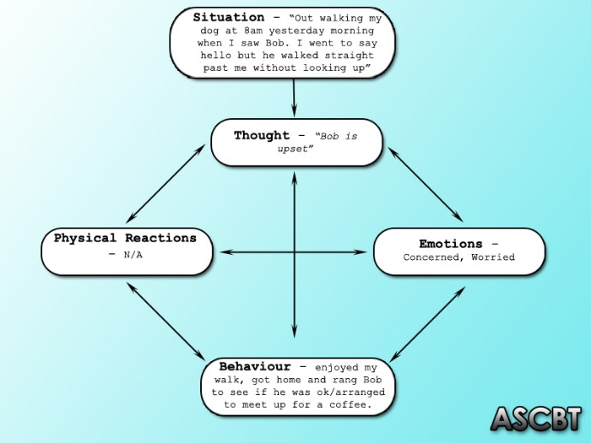

As you can see how we think about the situation influences our feelings, body and our behaviours. Even from the small situation Mary friendship with Anne may have been permanently damaged compared to the second scenario where Mary’s relationship with Anne was enhanced.

The challenge now is to use the Five Hats of CBT in your life to tackle your depression. By enhancing, up skilling the hats of Thoughts, Body and Behaviours we massively influence emotions. In effect this is how we treat depression.

Can you think of an example from your own life? A good way to do this is to think of the last time you had a strong feeling sadness, anger, fear, anxiety? Work your way back, put the different hats and figure out the links between your strong Feelings and the Situation, Thoughts, Body and Behaviours. There is a blank Five Hats CBT model you can fill out

The power of our thoughts

Our thoughts influence how we see the world and our behaviours.

‘Imagine your driving your car you come to red light. You normally stop. Think about the following situation. You’re in the middle of a rough area of the city at 4 AM. No other cars are about. There are a number of people on the street, intoxicated. You come to a red light. Do you stop? In other words attitudes, interpretation and thoughts about the situation determines your behaviour.’

When it comes to depression, the heart of this work looks at what keeps the depression going in the here and now. Many times our moods (sadness, fear, anger, irritable are keep going by a continuous negative automatic thoughts NATS and core beliefs. Often people mistake CBT with just replacing these NATS with positive thoughts. No. That is too simplistic. The secret is to target the NATS and change them to thoughts that are more realistic and balanced. Then it’s about understanding the pattern of these NATS and the core message they are revealing. It’s then we started tackling that negative core message.

We will now look at practical techniques on how to change negative thinking and beliefs and employ behavioural skills in combating depression. Therapy can also help you work through the root of your depression, helping you understand why you feel a certain way, what your triggers are for depression, and what you can do to stay healthy. I believe your counselling /therapy needs to be active, that there is a confiding relationship, a sense of hope, the exchange of information, opportunity to vent emotions, opportunity to acquire insight, the building of a platform of success which is dynamic and results orientated i.e. where you are working together with the tools necessary to manage and banish depression from your life.

The Thinking – Feeling Connection

The core concept of CBT is that our thoughts make the world. Epictetus, 55 – 135 ad noted ‘People are disturbed not by events, but by the view they take of them.’ In the therapy room people say ‘he made me feel bad’ or ‘my boss makes me nervous’ but in reality what really makes us feel and respond the way we do is our thoughts and beliefs about the events.

Imagine if I could scan a person’s brain and take a photocopy of the thoughts of a depressed person. Extensive research indicates that a depressed person thinks negatively about their past present and future. These negative automatic thoughts (NATS) are a central what keeps depression going. Imagine these thoughts like a software code, a set of instructions that we don’t see but works a application such as Facebook, Google, Amazon etc. When it comes to depression there are many faulty ’soft ware codes’ that keep the depression going. I often refer to this as crooked or a faulty thinking. You can refer to Appendix 1 – Crooked Thinking.

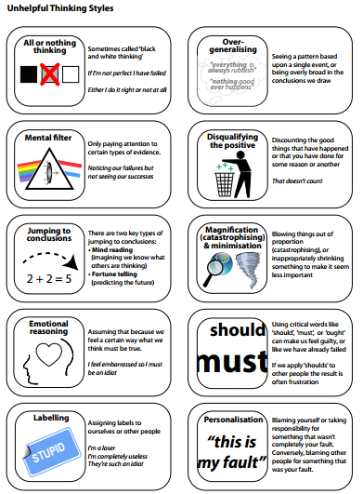

The bottom line is that negative thinking is the equivalent of putting petrol on a fire in that it keeps depression going. In addition this impacts on our behaviour, feelings and body. Take George for example;

George is 48. He is married to Patricia and they have three children. Roisin 10 yrs, Saoirse 7yrs, and Paul 5 yrs. George had a successful courier business up until 2009. He worked hard with his wife Patricia to build up the business. His business began to go downhill after the economic crash in 2008. He told his story ‘Like many small businesses I was left owed a lot of money and had accumulated massive debts. I had no option but to declare myself bankrupt. The ultimate humiliation was when the debt collectors came to my door. They took away my car and van that I used for business. How was I now going to provide for my family. I am a failure. Surely it’s a man’s job to provide for his family. At one time nothing could stop me. I was respected. Now I am nothing. My mood started to change quickly. I was angry all the time. I was angry with my children why love dearly. I was angry with my biggest supporter in my life Patricia. I lost all joy for living and became depressed. I know Patricia is worried about me because she sees me down, not going out, not having fun with the children and in terms of our sex life, it’s non-existent. Now I can go out, I can’t face anybody. I sleep in for as long as I can. The rest of the day, I stay indoors watching television. I used to run but I don’t have the energy to do this anymore.

The lack of communication lead to feelings of worry for the whole family. When George came to therapy he told me how feelings of depression and darkness had taken over his life."I do not want to get up in the morning. I dread seeing the post man walking around as I wonder what bills or warning letters are coming in the post to me. I feel life is not worth living as I have let down everybody. I can no longer provide for my family.'

When it comes to depression it’s clear that the thoughts, behaviours, feelings and physical sensations all interact to keep the depression going. This is represented in the following diagram

Sometimes people can struggle to distinguish between thoughts and feelings. A useful way I have found to tell mood / feelings can be described in one word see below
Words that describe feelings

Depressed
Guilty
Sad
Overwhelmed
Trapped
Angry
Happy
Irritated
Anxious
Relax
Uneasy
Tense
Nervous
Jealous
Uneasy
Panicky
Scared
Calm
Shame
Grief
Worthless
Loss
Alone
Fatigue
Humiliated
Tired

When it comes word thoughts most often they are automatic. Imagine when we drive our, we are often not aware of thinking. In fact some of our thinking is so habitual Car the car Just like when we are driving a car we are not aware of are thinking .

In order to capture your thoughts think about your thoughts like sentences

George’s depression distorted his thinking. He believed that his family felt he was not of value to them anymore because he could not provide for them.

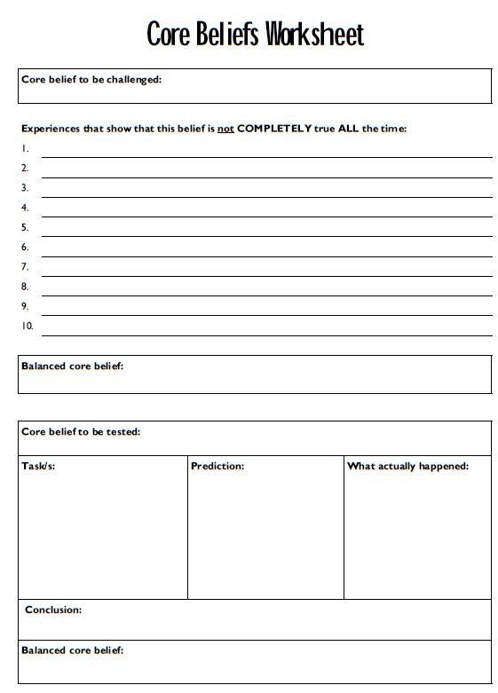

Through improved communication with his wife Patricia she told him of how much he was loved and cared for by her and his three children. He was reminded of a time before he became a successful business man when he and his wife and children enjoyed simple times. They had less stuff and more fun.

Thought Record

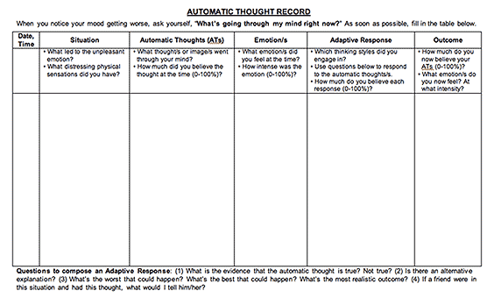

Now imagine you were more aware of these thoughts and you had the tools to control them. It’s when you change your thoughts you can change your world.

Themselves:
- I'm boring
- I'm Ugly
- I'm a failure
Others:
- No-one likes me
- Everyone is better than me
The future:
- Things will never get better
- What's the point?
People's behaviour patterns also typically change if they low or depressed. For example, they tend to spend a lot of their time indoors (often in bed) and don't socialise or do as much as they used to.
What causes depression?
Life Events:
We can feel depressed for a variety of reasons. However often depression can follow difficult experiences (such as a bereavement, being bullied or the end of a relationship). It is normal to feel low during such times and often these feelings pass naturally with time, but unfortunately sometimes they stick around for longer and become problematic. On the other hand, sometimes depression can seem like it comes 'out of the blue' for no particular reason at all.
Thinking Styles:
One theory suggests that the way we interpret, or think about things, can lead us to feel depressed. This is because how we think affects our emotions. For example, if you walked past a friend in the town centre and they ignored you, it would be easy to think this was because you've upset them, or that they dislike you. Of course having such thoughts would naturally cause you to feel upset and bring you down. On the other hand, if you instead thought; "perhaps they were daydreaming and didn't notice me," you would likely feel better about yourself. When we are depressed, we commonly think about situations in an overly negative manner (as described above) and this has a negative impact on our mood.
Behavioural Explanations:
Another popular theory is that depression can occur because we stop doing many of the things we used to enjoy (such as socialising with friends and participating in our hobbies). This often means we have little to look forward to which can make our lives seem boring and meaningless. Instead when we are depressed we tend to spend most of our time alone or sitting in front of the TV and this can become very unrewarding and unsatisfying.
Biological Reasons:
It has also been shown that depression can have familial ties. For example, if someone in your immediate family has experienced depression, there is an increased chance that you will develop similar feelings. It is therefore thought that our genetic make up plays a role.
In reality it is likely that a combination of all these factors play a role in people becoming depressed or low. However, in some ways it is less important to know what causes depression and more important to know what stops us moving past it.
What keeps our depression going?
When people are depressed, they often have a negative way of looking at themselves, the world and their futures. Some believe that people's tendency to think in this negative fashion is one of the important factors in ensuring their depression continues. It clouds the way they interpret situations and helps ensure they continue to have a negative outlook on life.
Furthermore when people feel depressed or low, they often stop being as active as normal, and spend less time socialising or engaging in their hobbies. This means that they have less pleasure in their lives and little to look forward to on a day to day basis, which too can keep them feeling low. Furthermore, when they are inactive, it normally leads to them feeling even more lethargic, which makes it even more difficult to escape this trap and a vicious cycle occurs.
Similarly, people who are depressed or low, often spend a lot of time lying in bed or sitting around watching TV. Often this leads to people feeling as though they have wasted their day and have achieved very little which makes them feel even worse. It also leaves them with plenty of time to beat themselves up or worry about their problems, which of course also makes them feel worse.
.
When looking more closely at what stops us overcoming our depression, it becomes clear that our behaviour, thoughts, feelings and physical sensations all interact and combine to keep our depression going. See the diagram below:

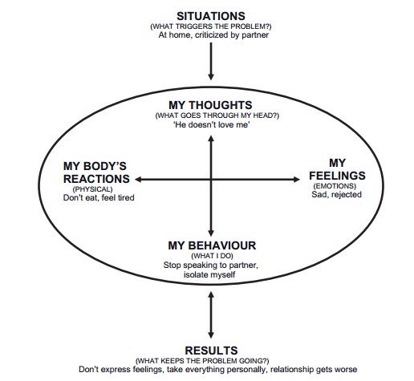

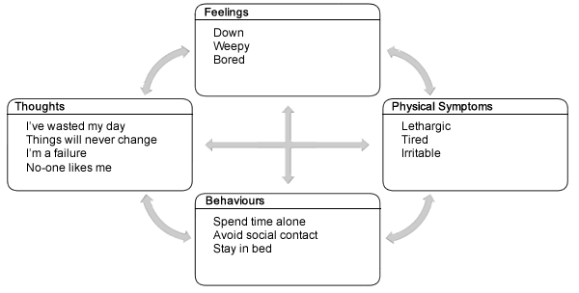
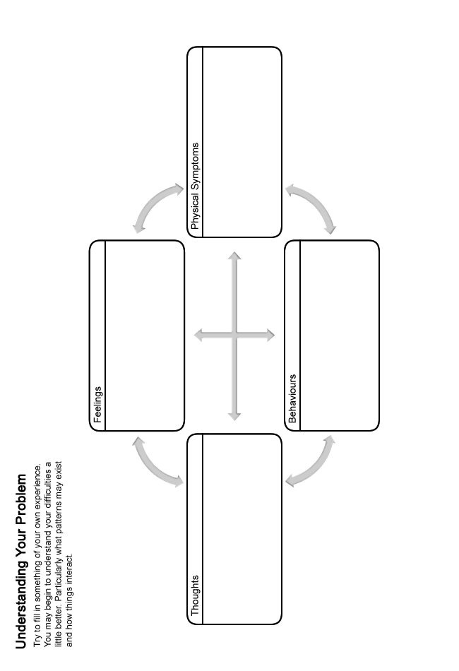
How can I overcome my depression?
Fortunately, there are a number of strategies that we can use to overcome depression and low moods. These include:
- Learning how to challenge your unhelpful thoughts and see things in a more realistic light.
- Learning strategies that can help you become more active and make good use of your time.
- Improving your problem solving skills.
- Learning ways to help you notice your qualities and achievements.
When going through this booklet it can sometimes be more helpful to try out the ideas above one at a time, rather and trying to learn them all at once. However simply take things at your own pace.
Challenging unhelpful thoughts
The way that we think about things has an impact on our mood. Many of these thoughts occur outside of our control, and can be negative or unhelpful. It is therefore important to remember that they are just thoughts, without any real basis, and are not necessarily facts. Even though we may believe a lot of our unhelpful thoughts when we are depressed, it is good to remember that they should be questioned as they are often based on wrong assumptions.
The following section will help you begin to recognise if you are thinking about things in an unhelpful or unrealistic way, and discuss how you can start to make changes to this. By doing so, you can learn to see things in a more realistic light which can help to improve your mood. You might have unhelpful thoughts about all kinds of things. Here are some examples:
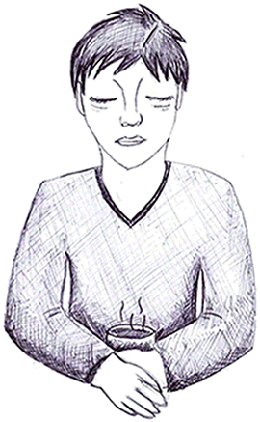
Yourself:
- I'm boring
- I'm ugly
- I'm a failure
Others:
- No-one likes me
- People are out to get me
- Everyone is better than me
The world:
- Life is unfair
- The world is a horrible place
The future:
- Things will never get better
- What's the point of continuing
- I'm destined to fail
It is clear to see how this kind of thinking might bring your mood and confidence levels down. Do you ever think in any of the ways outlined above? Fill in your examples below:
You might find it difficult to identify an unhelpful thought. Try thinking about a time when your mood changed. Consider what was running through your mind at that time.
Patterns of unhelpful thinking
First you need to be able to recognise an unhelpful thought. Then you can challenge it. Being aware of the common patterns that unhelpful thoughts follow can help you to recognise when you have them. Here are some of the common patterns that our unhelpful thoughts follow:
Predicting the Future:
When we are depressed, it is common for us to spend a lot of time thinking about the future and predicting what could go wrong, rather than just letting things be. In the end most of our predictions don't happen and we have wasted time and energy being worried and upset about them. For example:
- You have an exam and spend the week before predicting you will fail, despite all your hard work studying and your previous good grades.
Mind Reading:
This means that you make assumptions about others' beliefs without having any real evidence to support them. For example:
- My boss thinks I'm stupid.
- People think I'm weird.
Such ways of thinking can soon lower our mood and self-esteem.
Catastrophising:
People commonly 'catastrophise' when they are feeling low, which basically means that they often blow things out of proportion. For example:
- They assume that something that has happened is far worse than it really is (e.g. that their friend is going to dislike them because they cancelled a night out).
- They may think that something terrible is going to happen in the future, when, in reality, there is very little evidence to support it (e.g. I'm going to get into serious trouble for calling in sick).
Taking Things Personally:
When people are feeling low, they often take things to heart. For example:
- Because one of your workmates seem quiet, you assume that it is down to something you said. Instead, in all likelihood, they are probably just having a bad day and will be back to their usual self tomorrow.
Should Statements:
People often imagine how they would like things to be or how they 'should be' rather than accepting how things really are. For example:
- I should have more friends.
- I should be more confident at parties.
Unfortunately when we do this, we are simply being critical of ourselves which brings us down. Instead it can sometimes help to accept that things can't always be perfect.
Over Generalising:
Based on one isolated incident you assume that all others will follow a similar pattern in the future. Basically, you find it hard to see a negative event as a one off which can leave you feeling hopeless. For example:
- After failing your driving test, you assume that you will fail everything else that you try in the future.
What If Statements:
Have you ever wondered "what if" something bad happens? For example:
- What if I go to a party and no-one talks to me?
- What if I make no friends when I start my new job?
This type of thought can often make us avoid going places or doing things that we would like and enjoy which too can contribute to us feeling low.
Black and White Thinking:
Often when feelin low, people see things as either black or white, there is no in between. For example:
- They will only accept an A in maths as good, a B or anything lower is a complete failure.
This too can make people feel as though things are never good enough which can contribute to low mood.
Ignoring the Positives:
Often people can ignore the positive aspects of life or situations, and instead focus on the negative elements. For example:
- You focus on the one person who dislikes you and forget that you have many friends.
This style of thinking stops us feeling good about ourselves and lowers our confidence.
Labelling:
People who are low often label themselves in negative ways. For example:
- I'm no good.
- I'm not worthy.
- I'm a failure.
- I'm boring.
It is easy to see how labelling yourself in such a way would lower your confidence and mood.
Do any of your unhelpful thoughts follow some of these patterns? Jot down any examples you can think of into the box below:
We can learn techniques to challenge these unhelpful thoughts. This can help to improve your mood. The next part of this handout will discuss how we can go about challenging our unhelpful thoughts. You may come up with a more balanced thought that is accurate and based on evidence.
How to challenge unhelpful thoughts
Once you have recognised an unhelpful thought the next stage is to challenge it. To do this, you can ask yourself a serious of questions. See the example below:
Situation: My partner hasn't called me after saying they would.
How you feel: Sad, empty and tearful.
Unhelpful thought: They're getting fed up with me!
Challenges to an unhelpful thought
Now you can challenge your unhelpful thoughts by asking these questions.
Is there any evidence that contradicts this thought?
- We were recently talking about moving in together one day.
- We've been getting on really well lately.
Can you identify any of the patterns of unhelpful thinking described earlier?
- I'm catastrophising. Based on their failure to call, I'm jumping to worst possible conclusion.
- I'm also mind reading and ignoring the positives.
What would you say to a friend who had this thought in a similar situation?
- I'd say - they're probably just busy, stop stressing; they'll no doubt call soon.
What are the costs and benefits of thinking in this way?
- Costs: It's really getting me down and I can't concentrate on anything else. I'm also feeling sick with worry.
- Benefits: I can't really think of any.
Is there a proactive solution to this unhelpful thought?
- I could give them a quick call to see how they're getting on.
Is there another way of looking at this situation?
- They're probably just busy and will call soon
Once you have asked yourself these questions, you should read through your answers. Try to come up with a more balanced or rational view. For example:
I'm sure there'll be a good explanation as I don't have any evidence that suggests they're fed up with me.
Try to apply these questions to the unhelpful thoughts that you notice. It can help to improve your mood. You can use this technique to test your thoughts are realistic and balanced.
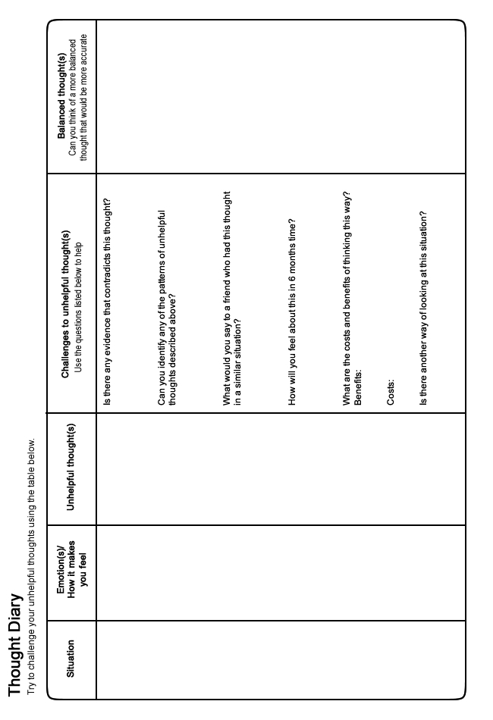
Making Good Use of Your Time
When we feel are depressed, our motivation to do things often decreases. You may find that you give up hobbies or activities that you previously enjoyed. Over time you might end up doing very little. This can lead you to feel even lower and a cycle can begin which is difficult to escape from.
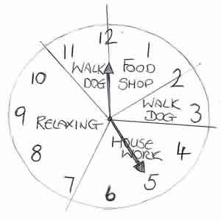
By using a diary to plan your week in advance, you may be able to do more of the things you want to, in addition to the things that you have to do. This can really help to lift your mood. This section aims to give you advice that will help you to plan your weeks well.
When completing your diary, start by filling in all the activities that you have to do. For example, preparing meals, doing housework, attending appointments, etc. This will show you all the time that you have free. Then you can begin to plan other activities that you would like to do. Remember to pace yourself. Give yourself space to be busy or take time out to relax. You may find it helpful to plan in some time for:
- Socialising � social contact often helps us feel better, even though you may not feel like it at times.
- Hobbies and interests � this might be something you have enjoyed in the past, or a new project.
- Exercise � this can improve your mood and general health. It doesn't need to be anything too energetic. Just going for a walk regularly can be a good option.
- Bedtimes - try to plan regular and consistent bedtimes. Having a regular sleeping pattern can help improve your mood and energy levels.
- Time for yourself - make time to relax and give yourself space between activities.
Some ideas have been provided in the box below that may help you get started. We all have different interests, so try to do things that you know will work for you. Fill in your ideas in the space provided:
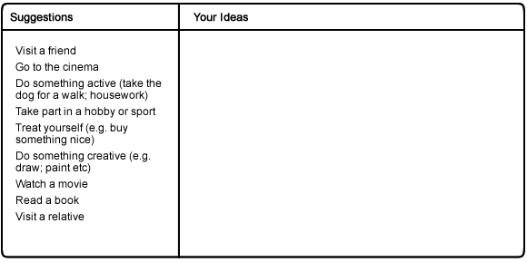
Now try to complete a plan for a week. You don't have to fill in every space - this can be quite difficult. You could start by just adding in one or two new activities for each day.
Once you have filled in your diary, all you have to do is try to follow your plan each day. Don't worry if unexpected things come up and you cannot stick to it exactly. In fact, it is very unlikely that things will go exactly as you planned. It is also fine to be flexible and replace some activities with new ones. Leave out some tasks altogether if you don't have time for them. Try to be relaxed if this happens.
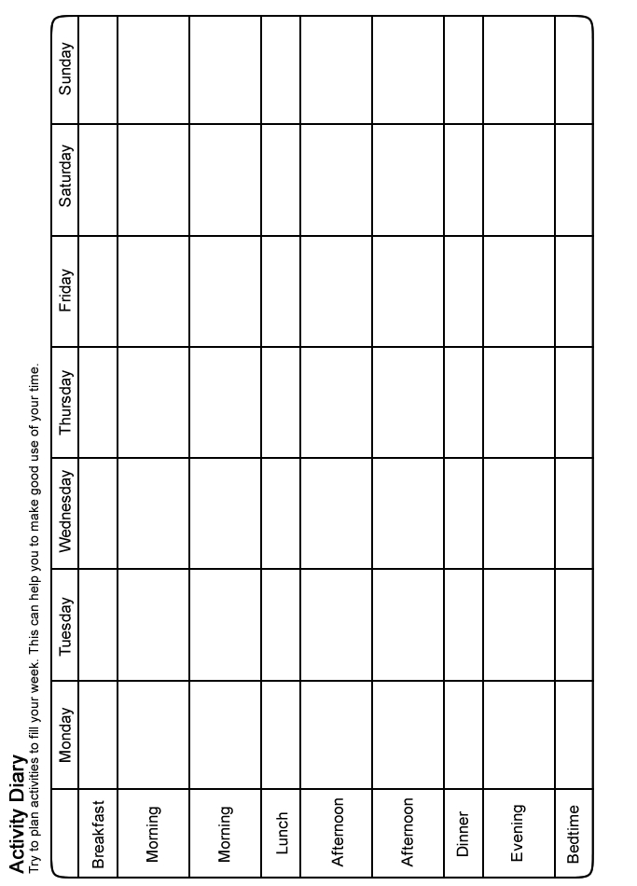
Problem Solving
You might find it more difficult to cope if you have lots of problems that you can't seem to get on top of. This can have a clear impact on our mood. Struggling with unresolved problems can often make us feel worse. We can end up worrying or ruminating over our problems without finding a way to resolve them. This can make us feel even more upset, and can end up interfering with our sleep.
It can help to develop a structured way of working through a problem. Beginning to overcome some of your problems might help you to feel better. You can improve your problem solving skills by learning to apply the steps outlined here.
Identify your problem
The first thing to ask yourself is � "what is the problem?" Try to be as specific as possible. For example:
- "I owe �400 to my friend."
- "I am going to miss this deadline."
Come up with possible solutions
Try to list every way that you can think to overcome your problem. Don't worry about how unrealistic an idea seems. Write down anything and everything. The best solutions are likely to be the ones you think of yourself. This is because nobody really knows your situation as well as you do. It may help to consider:
- How you might have solved similar problems in the past.
- What your friends or family would advise.
- How you would like to see yourself tackling the problem.
Choose a solution
Next you need to select the best solution from your list. Think carefully about each option. It is useful to go through all the reasons 'for' and 'against' each idea. This will help you to make a good decision and select the best solution.
After this you may find that you are still unsure. Perhaps a couple of approaches seem equally good. Try to pick one to begin with. If it doesn't work then you can always go back and try out a different one later.
Break down your solution
To help you carry out your chosen solution, it can be useful to break it down into smaller steps. This can make it easier and more manageable to follow through. The number of steps required will vary depending on the solution and how complex it is. For example: Someone with debt may have decided to try and resolve their problem by getting a part time job. This would require several steps.
- Buying a newspaper with job adverts.
- Choosing which jobs to apply for.
- Creating a CV.
- Sending out their CV.
- Buying interview clothes.
- Preparing answers to potential interview questions.
Try out your solution and review the outcome
Follow the steps required to carry out your solution. Simply take them one at a time. Go at your own pace and don't allow yourself to feel too rushed.
Once you have completed all the steps, you should then review the outcome. If you have successfully resolved your problem then great. If the problem still exists then don't give up.
- Is there another solution on your list that you could try?
- Is there a different solution that you have yet to consider?
- Can you ask someone else if they have any ideas or advice?
- Can you combine any of your solutions?
It is useful to remember that not all problems are within our control. This can make it really difficult if not impossible to resolve using the steps above. Perhaps you will have to wait, or ask someone else to take action instead. In such a situation, try not to worry. Nothing can be gained from worrying about something that you have no control over.
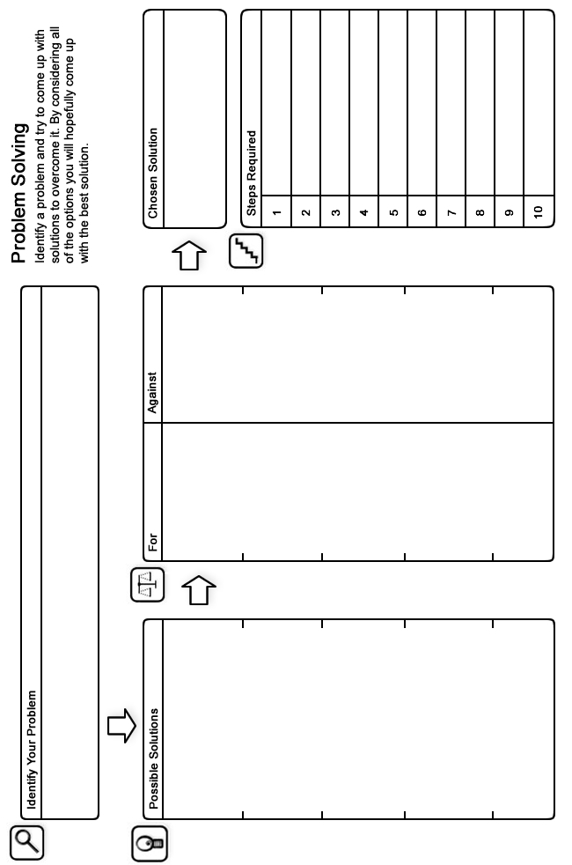
Recognising your qualities and achievements
Throughout life we often only remember the bad things that people have said about us or the times we feel like we have failed. This unsurprisingly lowers our mood and self-esteem. You can change this by beginning to remember the skills you have, the qualities you have and the achievements you have made. The evidence is there if you look for it!
It can help to consider:
- Things you do well.
- Things you have achieved.
- Times you did something even when it was hard.
- Things you know a lot about.
- Things you can do easily and quickly.
- Evidence that shows you are good at something.
- Things that you do that people have thanked you for.
- Times you were helpful to others.
- Evidence that people like you.
- Compliments you have been given.
- Qualities you have.
- Anything that shows you have been appreciated.
- Times when people have been nice to you or did you a favour.
Note down the evidence
Start by considering the evidence from the past and present and noting it down; it may look something like this:
- I always have time for my friends.
- I stay calm in a crisis.
- My friend always says I'm funny.
- I was invited to my work mates' house for tea.
- I'm normally really well organised.
- My boss asked me to take on an extra project last week.
- My work mate brought me back a souvenir from their holidays.
- I have a responsible job.
Keep adding to the list
- Continually add more examples to the list as they happen in the future, no matter how small they may seem.
Keeping these examples in mind
- Study the list everyday, especially at times when you are feeling low.
Final Word
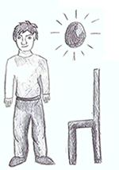
We hope that you found some of the ideas in this booklet useful. You can continue to use the techniques you found helpful long into the future and they should continue to benefit you. If some of the ideas are not particularly helpful at first, it is perhaps worth sticking with them for a few weeks to give them a chance to work. If however you feel your situation remains largely unchanged or if you did not find this booklet useful, you should speak to your GP who can tell you about the other options available which you could find helpful.
Further Information and Resources
For further information and self-help resources go to Moodjuice online:
http://www.moodjuice.scot.nhs.uk
Moodjuice is a website designed to offer information and advice to those experiencing troublesome thoughts, feelings and behaviours. In the site you can explore various aspects of your life that may be causing you distress and obtain information that will allow you to help yourself. This includes details of organisations, services and other resources that can offer support. This self help guide comes from a series that you can access and print from Moodjuice. Other titles available include:
- Depression
- Anxiety
- Stress
- Panic
- Sleep Problems
- Bereavement
- Anger Problems
- Social Anxiety
- Phobias
- Traumatic Stress
- Obsessions and Compulsions
- Chronic Pain
Some Useful Organisations
The following organisations or services may be able to offer support, information and advice.
Samaritans
Samaritans provides confidential emotional support, 24 hours a day for people who are experiencing feelings of distress or despair, including those which may lead to suicide. You don't have to be suicidal to call us. We are here for you if you're worried about something, feel upset or confused, or you just want to talk to someone.
Phone:
08457 90 90 90

Web Site:
http://www.samaritans.org
Breathing Space
Breathing Space is a free, confidential phone line you can call when you're feeling down. You might be worried about something - money, work, relationships, exams - or maybe you're just feeling fed up and can't put your finger on why.
Phone:
0800 83 85 87

Web Site:
http://www.breathingspacescotland.co.uk
Living Life to the Full
Living Life to the Full is an online life skills course made up of several different modules designed to help develop key skills and tackle some of the problems we all face from time to time.
Web Site:
http://www.llttf.com/
Further Reading
The following books may be able to offer support, information and advice.
Depression - The Way Out of Your Prison
Understanding and self-help methods of controlling depression are covered in this book.
Author: Dorothy Rowe
Published: 2003
Feeling Good: The New Mood Therapy
In clear, simple language, this book outlines a drug-free cure for anxiety, guilt, pessimism, procrastination, low self-esteem, and other black holes of depression. The techniques described will show you what you can do immediately to lift your spirits and develop a positive outlook on life.
Author: David Burns
Published: 2000
Mind Over Mood: Change How You Feel by Changing the Way You Think
Draws on the authors' extensive experience as clinicians and teachers of cognitive therapy to help clients successfully understand and improve their moods, alter their behavior, and enhance their relationships.
Author: Dennis Greenberger & Christine Padesky
Published: 1995
Overcoming Depression and Low Mood: A Five Areas Approach
This book contains a series of structured self-help workbooks for use by people experiencing depression. Developed in liaison with a wide range of health care practitioners, the course allows access to proven Cognitive Behaviour Therapy (CBT) approaches. With reading ages between 11 and 14, each workbook has been designed to offer essential jargon-free information and provides a carefully sequenced series of questions designed to bring about change in how the person thinks and what they do in order to improve how they feel.
Author: Chris Williams
Published: 2012
Overcoming Depression: A guide to recovery with a complete self-help programme
A self-help guide using Cognitive Behavioral Techniques, this book is full of step-by-step suggestions, case examples and practical ideas for gaining control over depression and low mood.
Author: Paul Gilbert
Published: 2009

